Trading Master Using Python

Hardik Gupta  
Computer Science and Engineering  
MIT - School of ComputingPune, India  
  
  
Piyush Marathe Computer Science and Engineering  
MIT - School of ComputingPune, India  
  
  
  
Vedant Amarshettiwar   
Computer Science and Engineering  
MIT - School of ComputingPune, India  
  
   
 Shardul Mundwadkar  
Computer Science and Engineering  
MIT - School of ComputingPune, India

Prof. Avinash Ingle  
Computer Science and Engineering  
MIT - School of ComputingPune, India

***Abstract*—With an unprecedented leap in the field of technology and science, we have reached to a point where each and everything around us is being controlled by machines and are helping the mankind to achieve something or the other, be it calculating scientific data or day to day activities. Data Science fields, such as Machine Learning, Deep Learning, Artificial Intelligence have always acted as revolutionary agent in the various fields of analysis and predictions. Machine learning provides the machine with the ability to automatically learn and improve from experience without being programmed. Deep learning is a subset of Machine Learning where artificial neural networks, which are stimulated by the human neural network, that is learning from a large dataset and represent it for the understanding purpose. In this project, we are making use of APIs to get real time data from two largest online cryptocurrency trading and statistics platforms, that provides us with more accurate data that is being refreshed after a certain interval of time. Machine Learning algorithms have the ability to discover the various trends and patterns in the cryptocurrency data and use them to make more accurate predictions of its future value. Cryptocurrency data is a type of time series data which is generated every second. Time series analysis applies various statistical analysis techniques on the historical cryptocurrency data to find trends in the cryptocurrency prices and the various other characteristics of the data.**

***Keywords—Cryptocurrency, Moving Average, LSTM, Future Prediction, API, Deep Learning***

# Introduction

Time series data is a category of historical data that resembles a collection of data that has been made through time and is organised according to a continuous time period. It essentially depicts the value of a specific variable at several times in time. Any format, including daily, weekly, monthly, and yearly, can be used for the data. A time series data typically includes the following elements: Level – It is the baseline value of the given time series. Noise – It is defined as the data points that have some exceptional value that cannot fit in a model. Trend – The trend is the linear escalation or contraction of the series over a specific period of time. Depending on the time series data, it might or might not be present. Seasonality – It is defined as the repeating patterns or behavior of the series over time. It is also optional. .

A variety of techniques can be employed for time series analysis, which is the study or analysis of time series data. Time series analysis is done to look for trends in the provided data and to look at the data’s numerous other features. There are many uses for time series analysis, but cryptocurrency analysis is one of the most promising. Time series analysis has two main objectives: To observe and understand the given data and find trends in it. To anticipate or forecast the values of a series using data that has already been observed.

We undertook this project to illustrate the significance of Technology and Data Science in the currency market and how we can take leverage it. In the past decade, we have witnessed an unprecedented rise of Cryptocurrency in the currency market. Cryptocurrency is backed by Blockchain Technology and has been recognized as one of the most efficient and safest way of making transactions. In this project we have utilized Machine Learning Algorithms and Time-Series for analysis and predictions using Python Programming Language.

Contextual data integration into the DL/ML model can be difficult since it necessitates the gathering and processing of new data sources. However, if done well, it might greatly increase the efficacy of phishing detection and aid in shielding people from phishing attempts.

Time series data is a category of historical data that resembles a collection of data that has been made over time and is organised based on a continuous time period. It includes a variety of methods for studying and analysing the data. Additionally, it can assist us in determining the data set’s trend. It essentially depicts the value of a specific variable at several points in time. The Time Series Data generally consists of the following components: Level, Noise, Trend and Seasonality.

In the present world we are witnessing technology growing at an unprecedented rate, however due to negative global cues the financial markets across the globe are not keeping up since a couple of year. So in this project we intend to combine the technology and finance field and seek to create a meaningful product from our work.When analysing a time series, different forecasting techniques are used to isolate various models from the gathered historical data. Then, using the premise that the information gathered from the past data will remain true in the future, we can use this data to predict future events from the occurred data. There are several methods that can be used for statistical forecasting such as regression analysis, decomposition method, neural networks etc. These techniques provide different forecasting models, each with varying accuracies. The main task is to base the accuracy of the predictions on the minimum obtained error of the forecast.

In this project, our main objective is to analyze the cryptocurrency data using different algorithms and to use that data to get meaningful insights about the cryptocurrencies. We will then use the results to find the most suitable cryptocurrencies for trading that can yield high profits to the traders in the future.

# Related work

A Comparison of ARIMA and LSTM for Time Series Forecasting Deep learning algorithms, in particular, have made fast strides in the development of sophisticated AI-based methods, and these techniques are growing in popularity among specialists in the field. The key question is then how accurate and potent these freshly developed procedures are in comparison to the traditional approaches. The accuracy of ARIMA and LSTM as representative systems for forecasting time series data is compared in this research. Models based on LSTM perform significantly better than models based on ARIMA.When these two approaches were used to analyse a collection of financial data, the results revealed that LSTM was superior to ARIMA. In addition, the LSTM-based algorithm outperformed the ARIMA-based algorithm in terms of prediction accuracy by an average of 85. The research presented in this paper promotes the advantages of using deep learning-based algorithms and methodologies to analyse financial data. ARIMA Model in Predicting Banking This paper demonstrates a model that presents short-term prediction of the new high technological system. After collecting adequate real data to develop a stock market data, an ARIMA model are implemented over the dataset performed to improve prediction. Application of the method in the case of banking stock exchange data verified its accuracy and showed its presentation capabilities. Around couple of hundred observations were gathered to implement the forecasts of this and the best ARIMA model was chosen dependent on the most acclaimed criteria which is MSE. Another significant observation is that the forecasting accuracy and consistency of the ARIMA model reduces gradually at this phase of the development procedure, from period to period. This model can be applied and appropriate for instances of the high-technology market particularly for the banks since it gives a significant pointer for the future.

A typical data science work is forecasting, which supports organizations with goal setting, capacity planning, and anomaly detection. Despite its significance, creating accurate and high-quality forecasts is difficult, especially when there are many different time series and analysts who are skilled in time series modeling are hard to come by. Prophet is designed for Facebook’s business forecasting tasks, which typically have one or more of the following features: hourly, daily, or weekly observations with at least a few months (preferably a year) of history; strong multiple human-scale seasonalities day of the week and time of year; significant holidays that occur at irregular intervals and are known in advance (such as the Super Bowl); a reasonable number of missing observations; or significant outliers.

J. Taylor and Benjamin Letham add that because forecasting is a specialised skill needing extensive experience, analysts who can make high-quality forecasts are consequently relatively uncommon. To prepare data for time series analysis, Aykut Cayr, Isil Yenidogan, Ozan Kozan, Tugce Dag, and Cigdem Arslan suggest conducting operations on it like time stamp conversion and feature selection.Despite the univariate nature of time series analysis, it aims to add a few extra variables to each model to boost forecasting precision. These extra variables are chosen in accordance with various correlation research. Aykut Cayr also suggests that the threefold splitting technique be used to choose the model for both ARIMA and PROPHET while taking into account the dataset’s time series properties. The best ratios for training, validation, and test sets can be obtained using the threefold splitting technique. Then, two distinct models are developed and their performance metrics are compared. According to the rigorous testing, PROPHET consistently outperform ARIMA.

Cryptocurrency price prediction has always been a notoriously difficult task and in order to carry it out using machines seems a little difficult because of various factors involved in the process. But it is rightly said that with escalation in technology nothing is impossible. With the advancing time and technology, people are getting more inclined towards investing in the cryptocurrency market which because of the high potential of return but is extremely volatile. The Trading System application implements the various concepts and techniques of time series analysis. It makes the process of analysis and prediction of cryptocurrencies extremely easy and user-friendly. Also with the help of the automated trading bot, the investor can employ it to generate profit for themselves.

# implementation details

## Dataset

Cryptocurrency data has a large number of attributes or variables that can be used to analyze and find trends in it: **Name:** It is the registered name or symbol of the cryptocurrency.

**Market Cap:** Market Capitalization is basically the total market value of the cryptocurrency.

**Price:** It is the current price of the cryptocurrency. It is very dynamic and generally changes every second.

**Volume (24h):** Volume is the amount of a particular cryptocurrency that has been traded in the last 24 hours. **Circulating Supply:** It is the amount of the cryptocurrency that is available at that moment for trading.

**Change (24h):** The change in the price of cryptocurrency in the last 24 hours.

## Methodology

A form of predictive analytics approach called time series analysis is used to forecast future values of a variable based on its observed past values. It entails using automated machine learning algorithms, analytical queries, and statistical analysis approaches to develop predictive models that put a numerical value on the likelihood that a specific event will occur. The software applications that carry out predictive analytics use different variables that are a part of the specified dataset to predict the future behavior of these variables with acceptable level of reliability. Cryptocurrency data has a large number of attributes or variables that can be used to analyze the data and find trends in it. The number and type of variables that can be used for the analysis totally depends upon the user and the machine learning algorithms being used. Generally, the data of cryptocurrencies has the following variables: Name: It is the registered name or symbol of the cryptocurrency. Some APIs provide data which does not contain the name of the cryptocurrencies. Instead, the cryptocurrency is provided with a unique ID.

**Predictive Analytics Process:** Predictive analytics techniques use various tools such as statistics, data mining, machine learning and data modelling to use the current set of data and predict the events in the future. The main advantage of using predictive analytics techniques with time series data is that it can be used to identify risks and explore ways to minimize those risks. Also, predictive analytics can be used to find out new business opportunities and use the data for their benefits. The process of predictive analytics is carried out in a number of steps or stages. The output of each stage completely depends upon the results provided by the previous stage. The final results obtained from predictive analysis are very promising and can be used for efficient decision making and future planning.

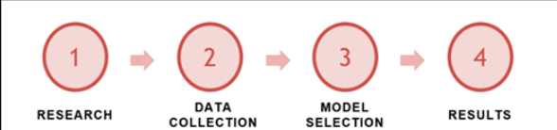

Research – The research stage is the initial stage of the predictive analysis process. It involves defining the main objectives of the analysis, identifying the preferable outcomes and finding the different datasets that might be required during the analysis.

Data Collection – In this stage, the datasets that are gathered during the research are combined together depending upon the type of datasets and analysis that has to be carried out. This provides the data from various sources as a single dataset. After this the data is cleaned and transformed to fit in the chosen predictive model in the next step.

Model Selection – Firstly, various statistical tools are used to analyze the data and find out how the data is inter-related and find the various trends and seasonality in the data. The results obtained are then used to find the most appropriate predictive model. The best way is to carry out multi-model evaluation.

Results – The predictive models provide predictions based on previous/historic data and these predictions are then converted into effective decisions. The models can be trained multiple times to make them optimal and get the desired results with maximum accuracy.

**Moving Average:** The Moving Average (MA) is a type of technical analysis tool that is used to smooth out time series data by constantly updating the average price. The most recent set of values for each prediction are used in the moving average method. The oldest observed value is subtracted from the set for each succeeding step while the anticipated values are taken into account.

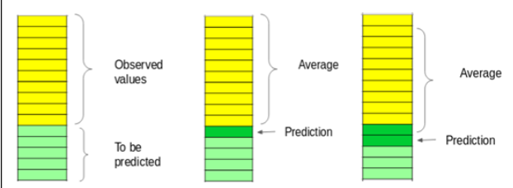

Since the average can be calculated over any time period that the trader selects, the moving average technique is frequently used for cryptocurrency analysis. The trading goals are the lone determinant of the moving average’s length. Longer moving averages are employed by long-term investors in the stock market whereas shorter moving averages are used for short-term trading. Moving averages also offer crucial trading insight. A cryptocurrency is in an uptrend if its moving average is increasing, whereas a downtrend is indicated by a moving average that is decreasing.

**Neural Networks:** A sophisticated algorithm used in predictive analysis is called a neural network. It functions much like how the human brain does. To predict future values and uncover any complicated correlations concealed in the data, neural networks process both historical and current data. On time series data, neural networks can be used to make predictions. A neural network can be created to recognise patterns in incoming data and generate noise-free output. A neural-network algorithm is composed of three layers: The following (hidden) layer receives past data values from the input layer. The neural network’s nodes are shown by the black circles. A number of intricate functions that build predictors are contained in the hidden layer; frequently, the user is not aware of these functions. At the hidden layer, a set of nodes represents mathematical operations that change the input data; these operations are referred to as neurons. The hidden layer’s predictions are gathered in the output layer, which then creates the model prediction as the end result. The neurons in most neural networks are activated via mathematical operations. In mathematics, a function is a relationship between a set of inputs and a set of outputs, where each input must equal one output.

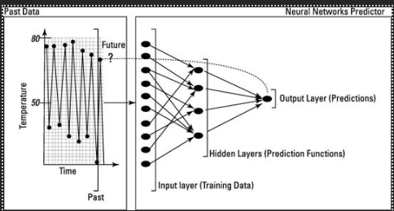

## Algorithm

## **Auto-Regressive Integrated Moving Average(ARIMA):** ARIMA is a statistical model for analysing and forecasting time series data and this approach combines two different parts into one equation; they are the Autoregressive(A R) process and Moving Average(MA) process, and build a composite model for the time series. The A R part of ARIMA indicates that the evolving variable of interest is regressed on its own lagged (i.e., prior) values. The MA part indicates that the regression error is actually a linear combination of error terms whose values occurred contemporaneously and at various times in the past. The I (for ”integrated”) indicates that the data values have been replaced with the difference between their values and the previous values (and this differencing process may have been performed more than once). The proposed BJ methodology for this research involves iterative three-stage cycles. The first step requires model identification. This stage finds the order of autoregressive, integration and moving average (p,d,q) of the ARIMA model :

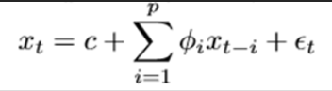

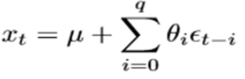

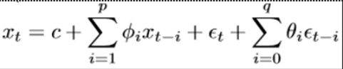

In this we have three steps, the first step requires model identification. This stage finds the order of autoregressive, integration and moving average (p,d,q) of the ARIMA model where p is the quantity of slack perceptions used in preparing the model (i.e., slack request) d is the occasions differencing is applied (i.e., level of differencing) and q is known as the size of the moving normal window (i.e., request of moving normal). Having identified the values of ARIMA model, the second step will be diagnostic checking. A simple test to ensure the chosen model best fitted is to test the residuals estimated from this model and check whether or not they are white noise. And if the residuals turned out to be white noise, then the model is accepted to have the particular fit; otherwise, the research process should restart over the selection process. The third step is the estimation of the parameters of the selected autoregressive and moving average forms included in the model. This step also involves forecasting the series based on the ARIMA model. A number of statistical measures will be used for this purpose. They are mean error (ME), mean absolute error (MAE), mean square error (MSE), mean percentage error (MPE).

**Long Short Term Memory Model (LSTM):** LSTM, also known as Long Short-Term Memory network, is the most commonly used Recurrent Neural Network for the analysis of time-series data. A simple RNN works fine with short-term dependencies. But while working with time series data, we require a neural network that is capable of dealing with long series of data. A LSTM network solves this problem by providing a long-term memory. LSTM networks can solve a large number of problems that cannot be solved by any other neural network. It has a unique ability to selectively forget or memorize certain data points. The data in a LSTM moves through different cell states. There are 3 different cell states in a common LSTM network: Previous cell state: The previous cell state is the data of the previous time-step. Previous hidden state: It is the output of the processed data of the previous cell state. Current cell state: It is the new data provided at that particular moment. While working with cryptocurrency data, the neural network should be capable enough to memorize the trend in the price of the cryptocurrency for the previous few days and use that information to forecast its future.

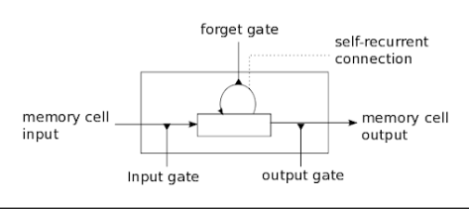

The data in the LSTM moves through different cell states with the help of a simple mechanism of gates. Each gate is responsible for controlling the flow of data from one cell state to another. Each memory cell of a LSTM network has an input gate that controls the data that is being added to the memory cell. It uses mathematical functions to filter the data before it is stored in a memory cell. These functions make sure that redundant data is not stored. The Forget Fate ensures that the less important data is removed from the memory cell. Removing the less-important data from the cell improves the performance of the neural network and it provides better results. The main use of the output gate is to select useful data available from the current state and provide it as the input to the next memory cell. The data provided by the output gate of one memory cell acts as the input to the another memory cell.

Time series analysis is a set of techniques that uses statistics to analyse and understand time-stamped data. Time series data consists of long chains of data that is broken down into small intervals of time. Analysis of data is carried out to find trends in the data and get useful insights about the data. Cryptocurrency data is a perfect example of time series data. The price of a cryptocurrency changes every second. This generates a large amount of timestamped data in real-time. Each cryptocurrency generates approximately 60 new data points every second and each data point further contains a number of different data attributes. To manage this amount of massive data, we require various techniques of time-series analysis. Time series analysis is carried out in different stages or steps. Some most commonly used steps in the process of time series analysis are: ETS Decomposition Exploratory Data Analysis (EDA) Data Smoothing

In contrast to modelling with regressions, there is a sequential dependence among the input variables in time series datasets. The dependencies between the input variables can be handled very effectively by recurrent neural networks. Recurrent neural networks (RNNs) of the LSTM variety can store and learn from lengthy sequences of observations. The Keras library is used to put the algorithm into practise. The dataset is first divided into 70 training and 30 testing sets, respectively, by the method (Lines 1-3). The LSTM model is trained and constructed by the algorithm’s ”fit lstm” function. The training dataset, number of epochs (the number of times a particular dataset is fitted to the model), and number of neurons (the number of memory units or blocks) are all inputs to the function. An LSTM hidden layer is created in line 8. The network needs to be built, then it needs to be compiled and parsed to match the mathematical notations.A loss function and an optimisation strategy must be given when building a model. The loss function and optimisation technique, respectively, are ”mean squared error” and ”ADAM”.

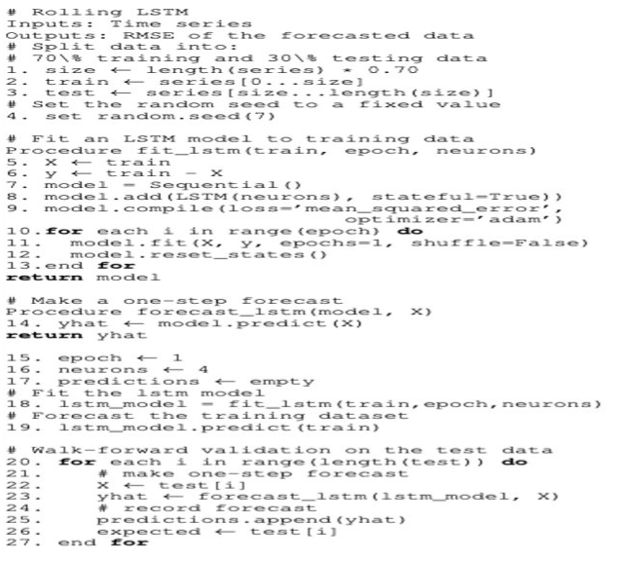

## User Interface

The User Interface (UI) of the Trading System is created using the Tkinter toolkit available for python.Tkinter is very intuitive and simple to use. There are many widgets available, including Buttons, Canvas, CheckButtons, Frame, Label, and ListBox. Tkinter toolkit also includes inbuilt configurations for the layout of the abovementioned widgets. We have used the pack and place layout configurations in the trading system.

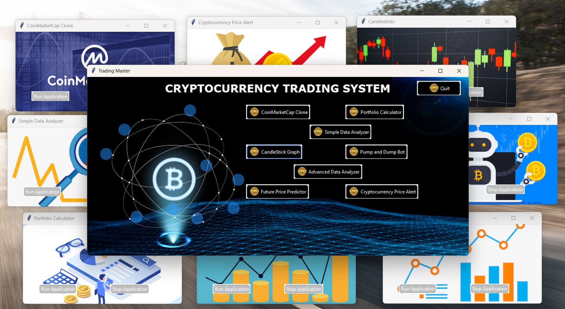

**Features offered by Trading Master:**

1. CoinMarketCap Application: CoinMarketCap has more than 5000 listed cryptocurrencies on its website with new data being added every second. The CoinMarketCap clone application allows an investor to view this data with ease. The application uses the listings API to get the latest data from the website. The data on the listings api is refreshed every 60 seconds. The application gets the data of all the cryptocurrencies and presents in it a simple and easy-to-understand tabular form. To make the data more presentable, we filter the data based on our preset conditions and display only the top 100 cryptocurrencies to the user. Further, to understand the data even better, we have provided some options to manipulate the data.

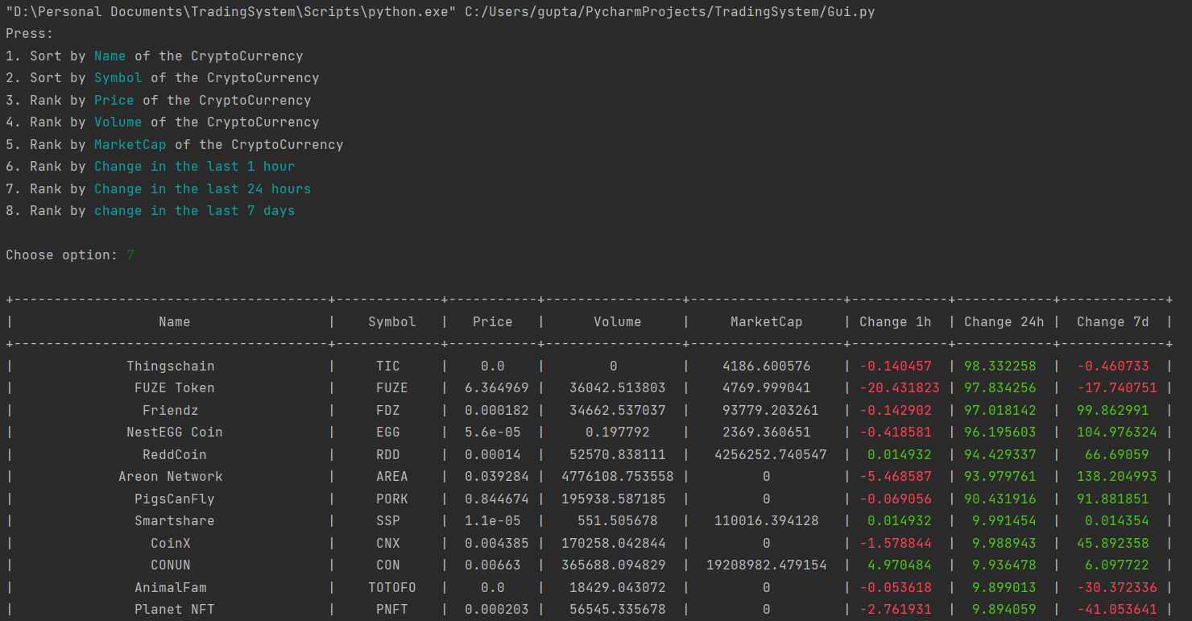

1. Portfolio Calculator: investor to view this data with ease. The application uses the listings API to get the latest data from the website. The data on the listings api is refreshed every 60 seconds. The application gets the data of all the cryptocurrencies and presents in it a simple and easy-to-understand tabular form. To make the data more presentable, we filter the data based on our preset conditions and display only the top 100 cryptocurrencies to the user. Further, to understand the data even better, we have provided some options to manipulate the data.

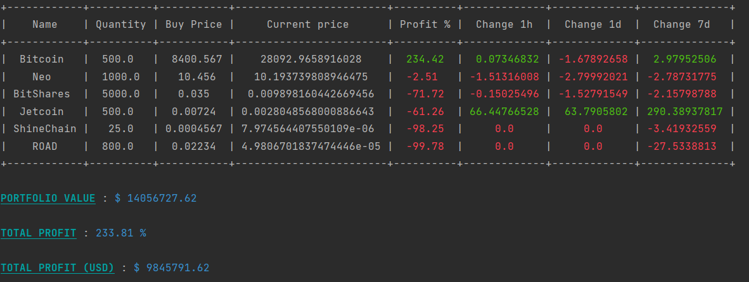

1. Price Alert: We have created a Price Alert Application as well. This application alerts the investor about any change in the prices of cryptocurrencies. Price alerts are really useful as sometimes it becomes difficult for an investor to notice some price changes. So we have also added a sound or tune which will ping like a notification every time there is a change in price of the digital currency. Thus, helping the investor by alerting about the price change. We have set particular limits in this application, both lower and upper for all cryptocurrencies for which we need an alert in case the price goes beyond the set limits.

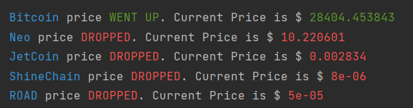

1. Simple Data Analyzer: We have developed a Simple Data Analyzer application as a part of our project. It uses the APIs from Binance that gives the possibility of calculating the change between the current price and the price from one year ago, six months ago etc. Basically, it is used to calculate the change between the current price and historical price. Again, it’s a statistical application that helps the investor to understand the cryptocurrencies better, the trends of change between them so that he/she can make appropriate calculations before investing their money in these digital currencies. There are many different columns/parameters that we have added in this application for better results and accuracy. These columns are: - 2mch: This represents the change between the current price and the price that was 2 minutes ago. 6hch: This represents the change between the current price and the price that was 6 hours ago. 12hch: This represents the difference in price between the present and the price that was 12 hours ago. 30dch: This represents the difference in price between the present and the price that was 30 days ago. 1ych: This represents the difference in price between the present and the price that was 1 year ago.

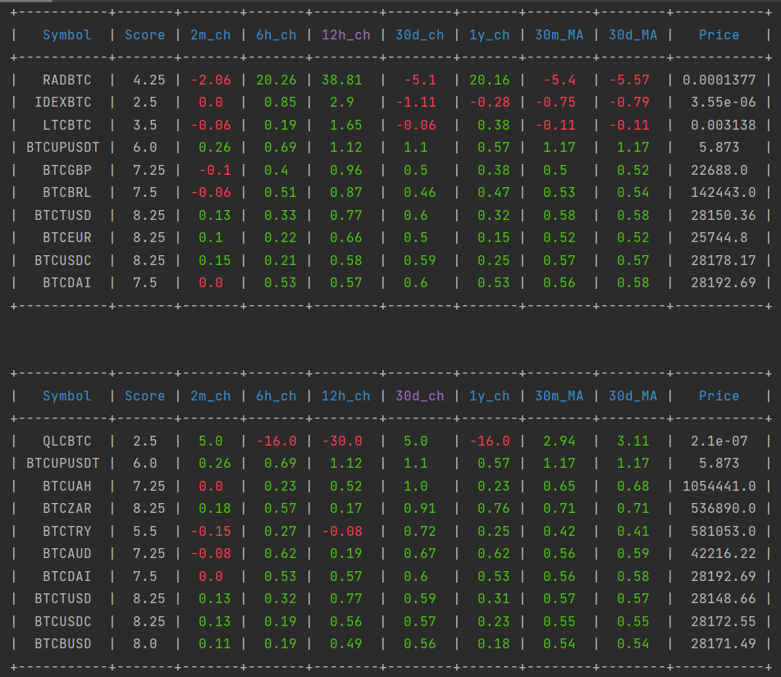

1. Advanced Data Analyzer: The Binance Data Analyzer application is the advanced version of the simple data analyzer. The Binance data analyzer can be used by traders for advanced trading with a lot more features. The application gets its data from the Binance website using the klines API. We request the data in two intervals; 1 minute and 15 minutes interval. First, the analyzer filters the data received via the website and finds the most traded cryptocurrencies on based on the preset conditions. Then the application starts to analyze the data of these cryptocurrencies and calculates a number of parameters that are essential to monitor the performance of the cryptocurrency. Some of these factors are: 2-min change: change in price in the last 2 minutes. 5-min change: change in price in the last 5 minutes. 15-min change: change in price in the last 15 minutes. 30-min change: change in price in the last 30 minutes. 1-hour change: change in price in the last 1 hour. 8-hour change: change in price in the last 8 hours. 10-min Moving Average: the moving average of price in the last 10 minutes. 20-min Moving Average: the moving average of price in the last 20 minutes. 50-min Moving Average: the moving average of price in the last 50 minutes. 100-min Moving Average: the moving average of price in the last 100 minutes. 1-day change: change in price in the last 1 day. 3-day change: change in price in the last 3 days. 5-day change: change in price in the last 5 days. 7-day change: change in price in the last 7 days. 10-day change: change in price in the last 10 days.

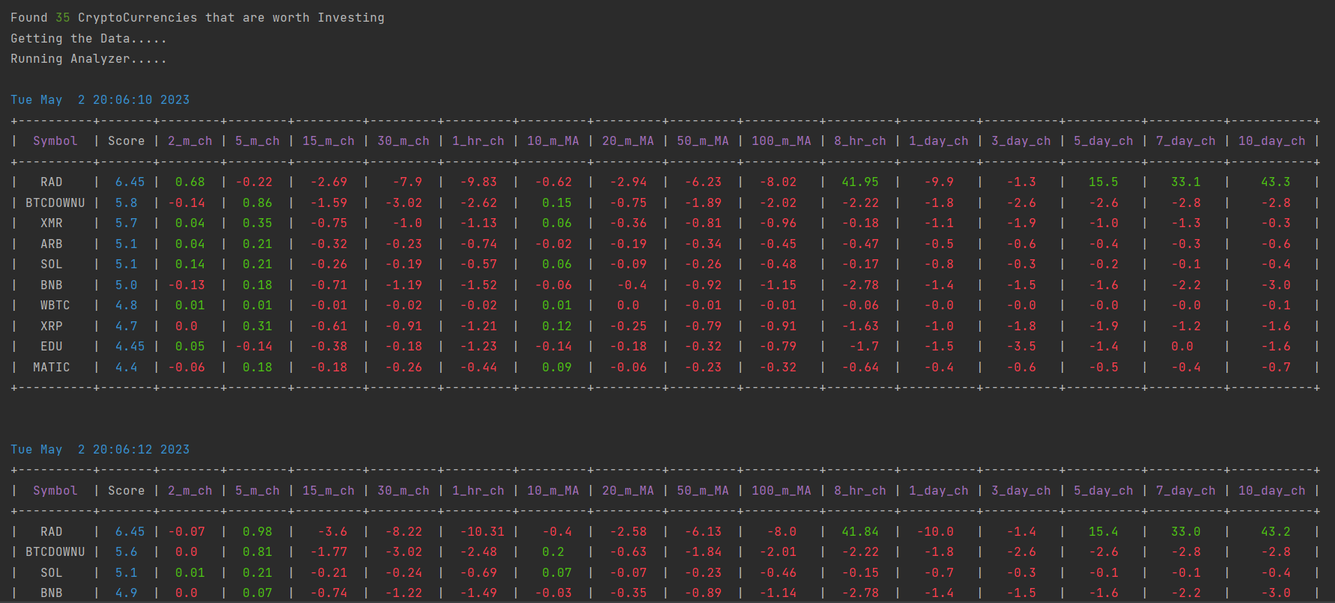

1. Future Prediction: The predictor application is the project’s last component. It is the crucial element of the trading system. The historical-klines API provides statistics on certain cryptocurrencies, like Bitcoin, Ethereum, and Litecoin, to the prediction application. The data is subsequently utilised to train an LSTM and dropout layer-based neural network model. Four LSTM layers, four Dropout layers, and one Dense layer make up the trained model. For each cryptocurrency, a brand-new model is created and saved. The model trained in the predictor is then loaded in the future-price application. When the future-price application runs, it first gets the historical data of the selected cryptocurrency. It also gets the current price of the cryptocurrency. The application then prompts the user to select the amount/quantity of the cryptocurrency that the user intends to buy. Finally, the application tries to predict the future value of the cryptocurrency based on the provided data. It informs the user weather the selected cryptocurrency will yield profit or loss in the future of upto 1 month. The application always works on real-time data and tries to provide results with maximum accuracy and least error in the predictions.

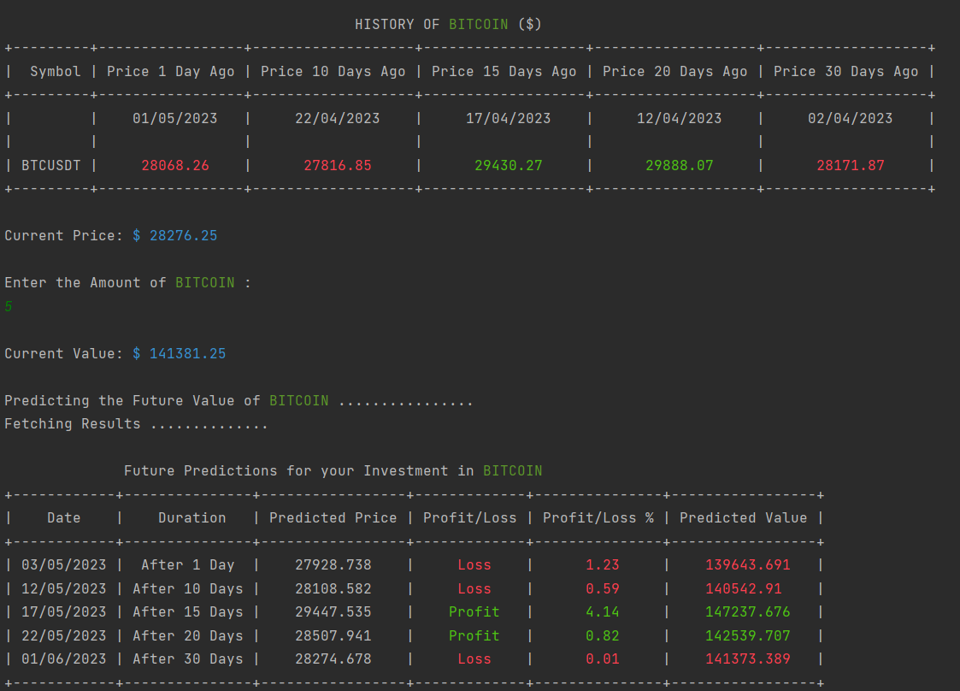

1. Candlestick(s) Application: A candlestick graph is the most commonly used technique to visualize time series data or more importantly financial data such as cryptocurrency data. It is used by traders or investors to understand the change/movement of price of the cryptocurrency over the past few days. The candlesticks application can be used to understand the data with visualization. The viewer can view the data as an interactive candlestick graph rather than having it presented as integers. The user can select the name of any cryptocurrency and visualize the performance of that particular cryptocurrency over the past years. A single candlestick graph provides a ton of information to the user such as the daily open, close, high and low price of the cryptocurrency. As it is an interactive graph, the user can easily select any particular time-frame to view the data in a more detailed form.

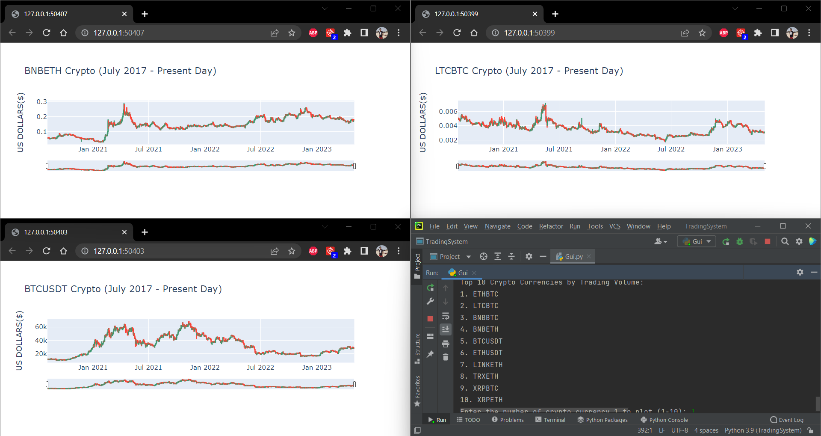

1. Pump and Dump Trading Bot: We have also created a Pump and Dump trading bot. It is an automatic buying and selling bot that reduces the efforts of investors and trades the digital currency automatically as per the instructions. We just need to set the certain parameters like the time for which the bot has to observe the price, particular cryptocurrency, the buying price, the buying quantity, the price at which we want to sell.Train the application with all these parameters and it will automatically buy the set quantity of the set cryptocurrency and will sell that quantity when the specified criteria are satisfied. Trading bot is a very useful application for such buying and selling operations as manually buying and selling at a very particular moment of time is a tedious task and requires a lot of accuracy. Trading bot saves all this time and enhances the overall experience

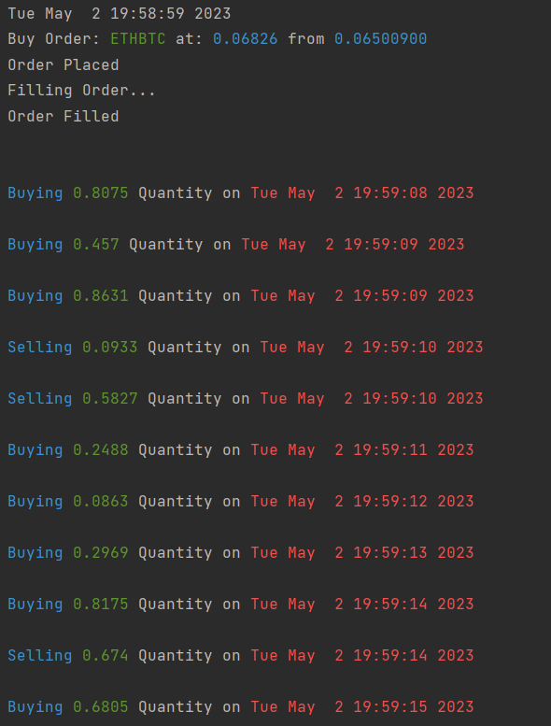

# Comparison with real price

Bitcoin: A comparison between predicted price and real price is done. Line Graph shows the comparison.

|  | Predicted Price ($) | Actual Price ($) |
| --- | --- | --- |
| 09-05-2023 | 26759.15 | 27658.77 |
| 10-05-2023 | 28561.15 | 27621.76 |
| 11-05-2023 | 27175.18 | 27000.79 |
| 12-05-2023 | 26736.65 | 26698.48 |

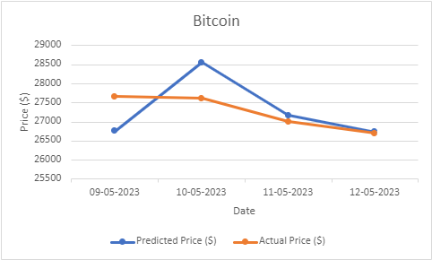

Ethereum: A comparison between predicted price and real price is done. Line Graph shows the comparison.

|  | Predicted Price ($) | Actual Price ($) |
| --- | --- | --- |
| 09-05-2023 | 1714.133 | 1848.6 |
| 10-05-2023 | 1844.185 | 1842.4 |
| 11-05-2023 | 1763.042 | 1796.49 |
| 12-05-2023 | 1721.088 | 1733.56 |

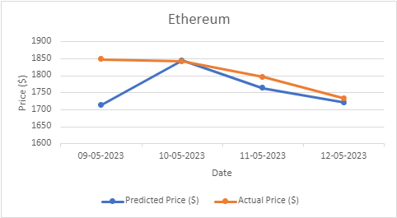

Litecoin: A comparison between predicted price and real price is done. Line Graph shows the comparison.

|  | Predicted Price ($) | Actual Price ($) |
| --- | --- | --- |
| 09-05-2023 | 80.111 | 80.02 |
| 10-05-2023 | 81.212 | 81.07 |
| 11-05-2023 | 82.486 | 81.04 |
| 12-05-2023 | 80.075 | 79.13 |

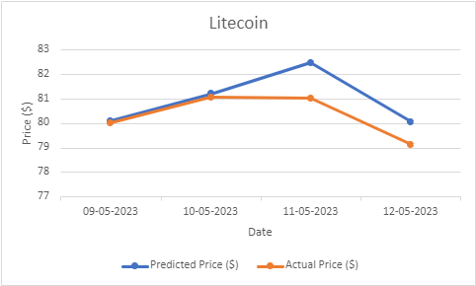

# Conclusion

In the modern world, evolution in the field of finance and technology is at record high. People are striving to leverage the technology, collaborating it with pre-existing human intelligence and experience in the economic and financial markets to make huge amount of money. Despite the unprecedented global market condition, growth of market capitalization of cryptocurrency remains on the positive side. Predicting the performance of a cryptocurrency is a difficult task. Analysis and prediction of cryptocurrencies involves many factors such as physical factors or physiological factors which makes the cryptocurrency prices highly volatile to predict with 100 accuracy. When analysing a time series, different forecasting techniques are used to isolate various models from the gathered historical data. Then, using the premise that the information gathered from the past data will remain true in the future, we can use this data to predict future events from the occurred data. In this project, we have made an API to collect the dataset of the user selected cryptocurrency on real- time basis from two online trading platforms, namely Binance and CoinMarketCap, post data collection, we employ the data in LSTM and this model helps us to analyze the dataset and find out the trend of the particular cryptocurrency. This analysis is done on the basis of numerous factors in term of volume traded in the last 24 hours, 52-weeks high, 52-weeks low, plunging patterns and other fundamental aspects. There is an option to view the data chart using the candlestick representation which is widely used to analyze the trend. Also, in the CoinMarketCap API we have provided the user with the option to show the list of cryptocurrency on the basis of factors such as Name, Symbol, Price, Volume, Market Cap and Change in Price. It helps user to get meaningful insights. Further, in the project, there is an advance data analyzer which employ the period change and moving average techniques to analyze the data. All these features are accessible to the user through a common UI, thus making it a complete user-friendly cryptocurrency trading system.

##### References

[1] N. A. Gershenfeld and A. S. Weigend, The future of time series. Xerox Corporation, Palo Alto Research Center Palo Alto, CA, USA, 1993.

[2] A. Kirlic and M. Had ´ ziˇ c, “Big data and time series: A literature review paper,” ´ Univerzitetska misao-casopis za nauku, kulturu i umjetnost, Novi Pazar ˇ , no. 16, pp. 139–146, 2017.

[3] P. D. DeVries, “An analysis of cryptocurrency, bitcoin, and the future,” International Journal of Business Management and Commerce, vol. 1, no. 2, pp. 1–9, 2016.

[4] L. Catania and S. Grassi, “Modelling crypto-currencies financial time-series,” Available at SSRN 3028486, 2017.

[5] M. Rauchs, G. Hileman, et al., “Global cryptocurrency benchmarking study,” Cambridge Centre for Alternative Finance Reports, 2017.

[6] M. Peixeiro, “The complete guide to time series analysis and forecasting,” Towards Data Science. https://towardsdatascience. com/the-complete-guide-totime-series-analysis-and-forecasting-70d476bfe775, 2019.

[7] P. T. Yamak, L. Yujian, and P. K. Gadosey, “A comparison between arima, lstm, and gru for time series forecasting,” in Proceedings of the 2019 2nd International Conference on Algorithms, Computing and Artificial Intelligence, pp. 49–55, 2019.

[8] D. Hagemann, “A time series analysis of crypto currency price data,” 2018.